1. Linux Launch Status:

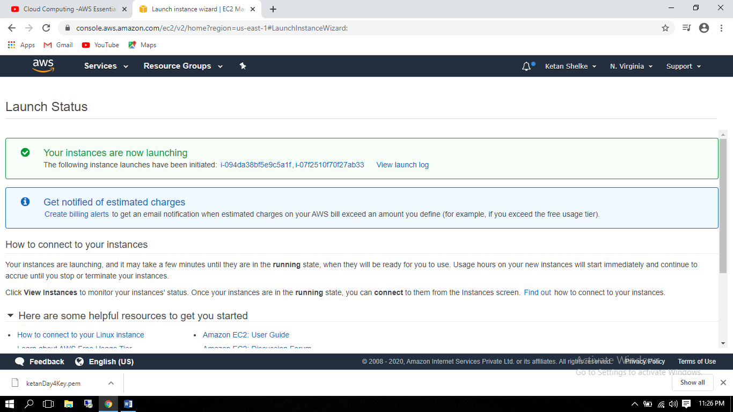

1. Linux1 Instance (34.235.122.112)

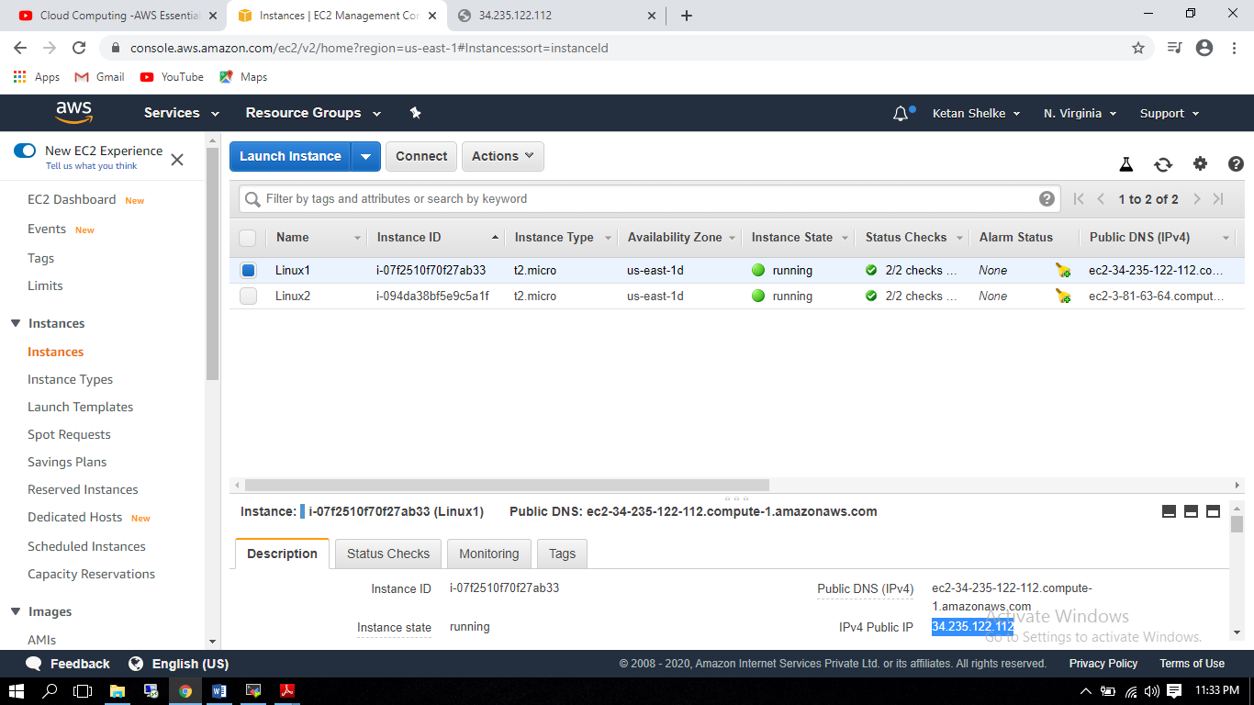

1. Linux2 Instance (3.81.63.64)

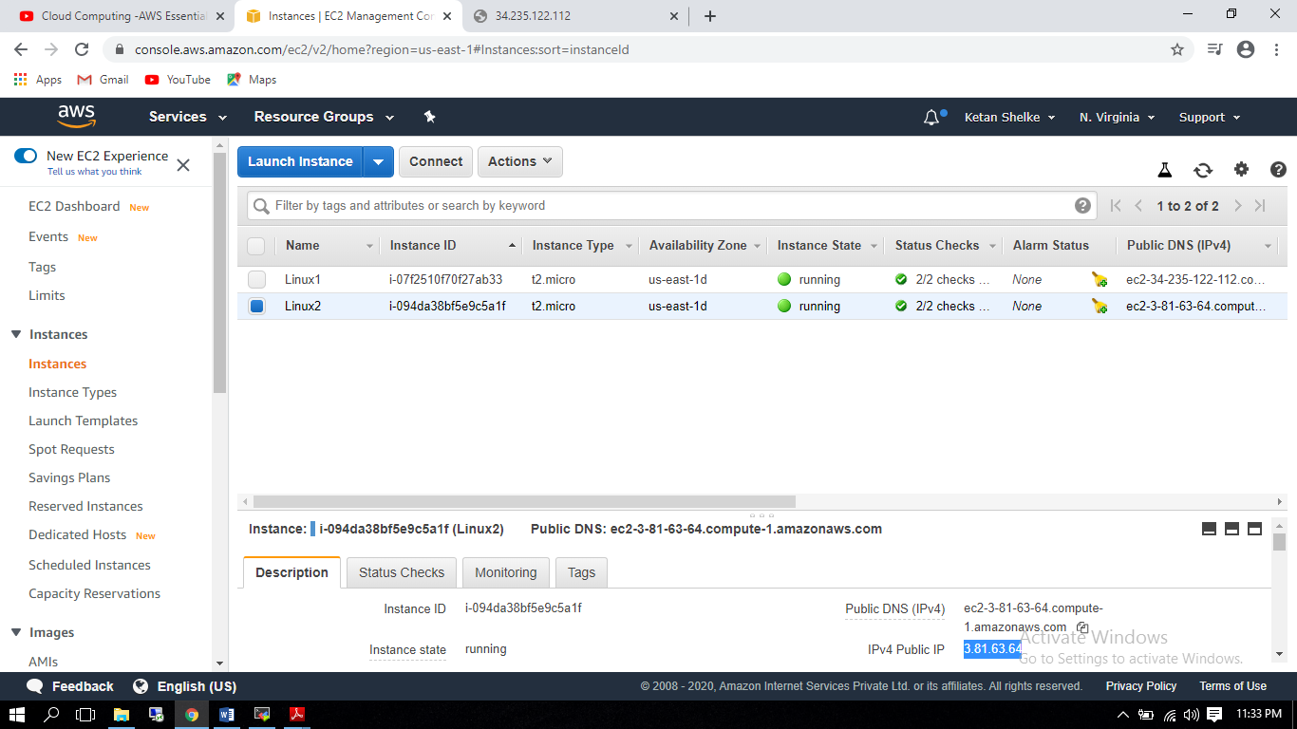

1. Linux1 Instance Output:

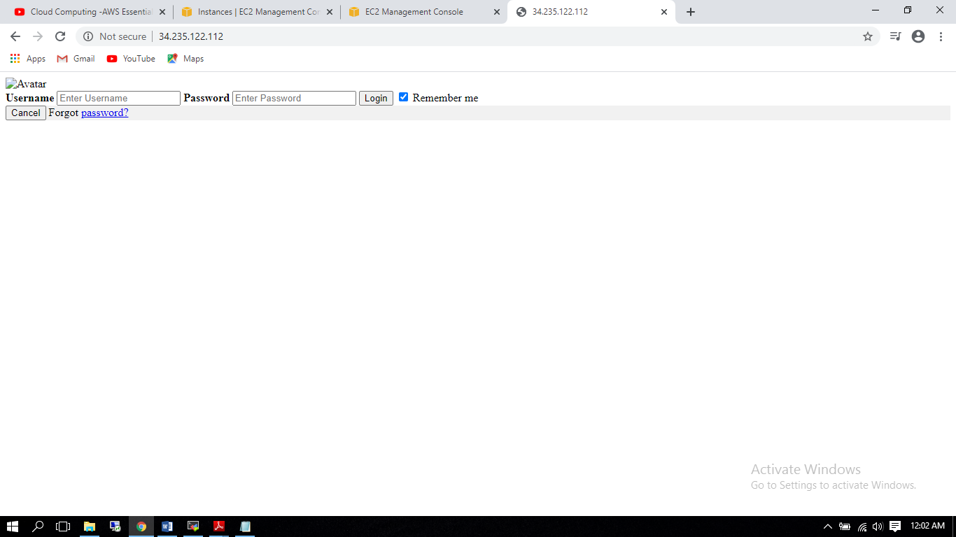

1. Linux2 Instance Output:

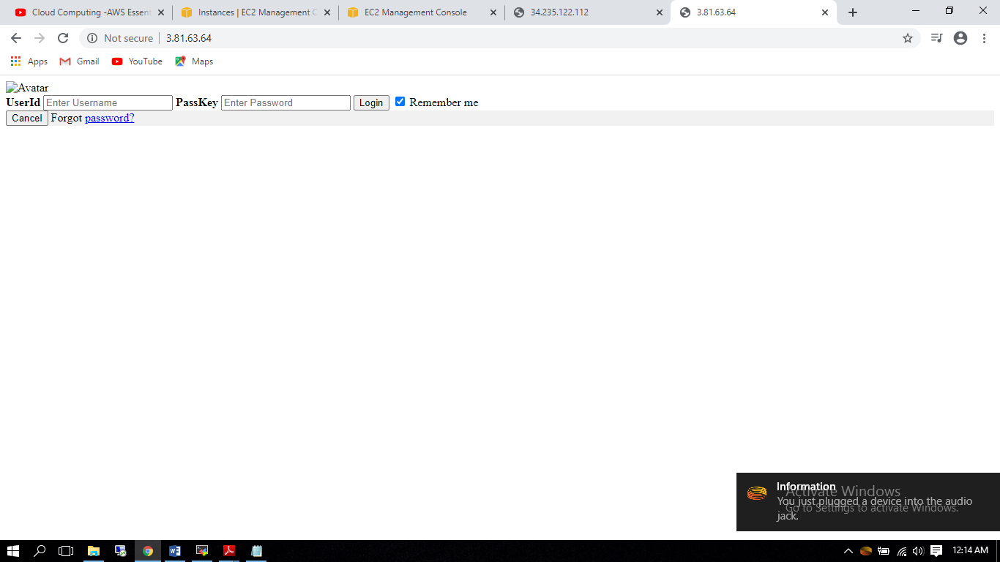

1. Load Balancer created:

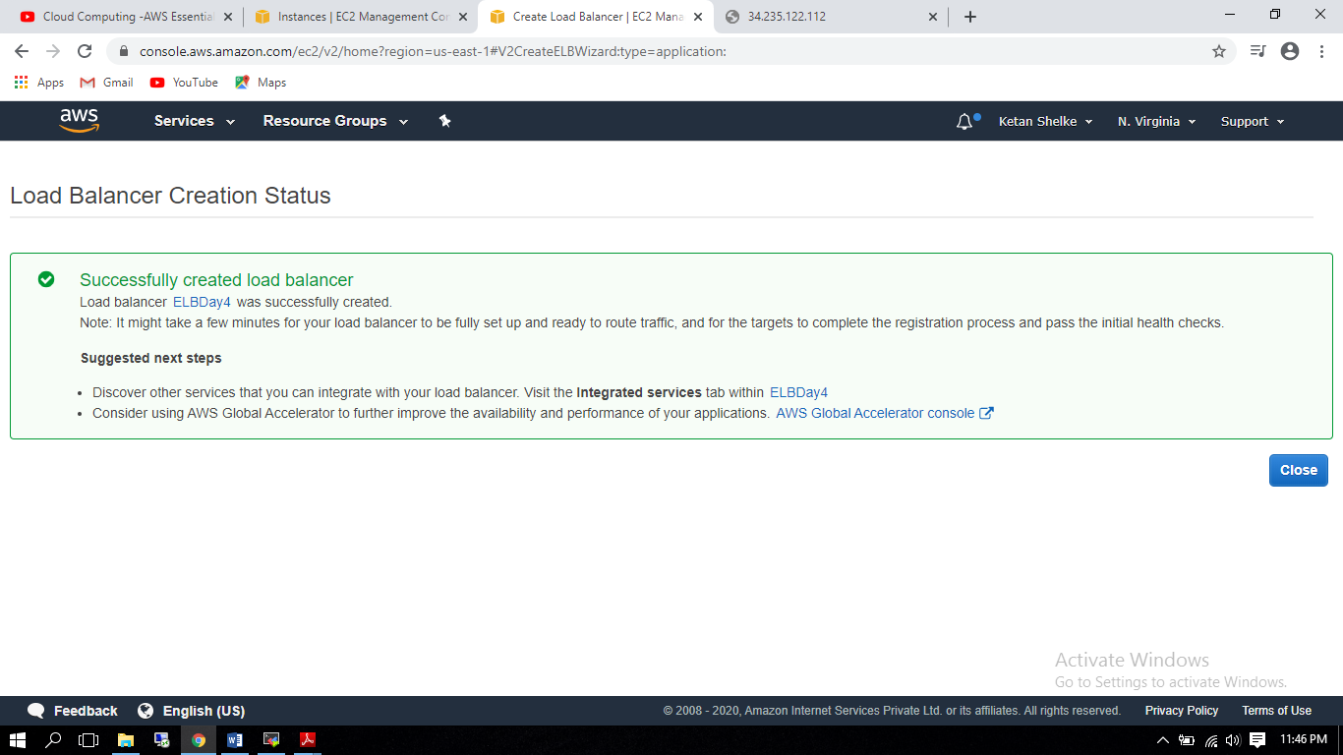

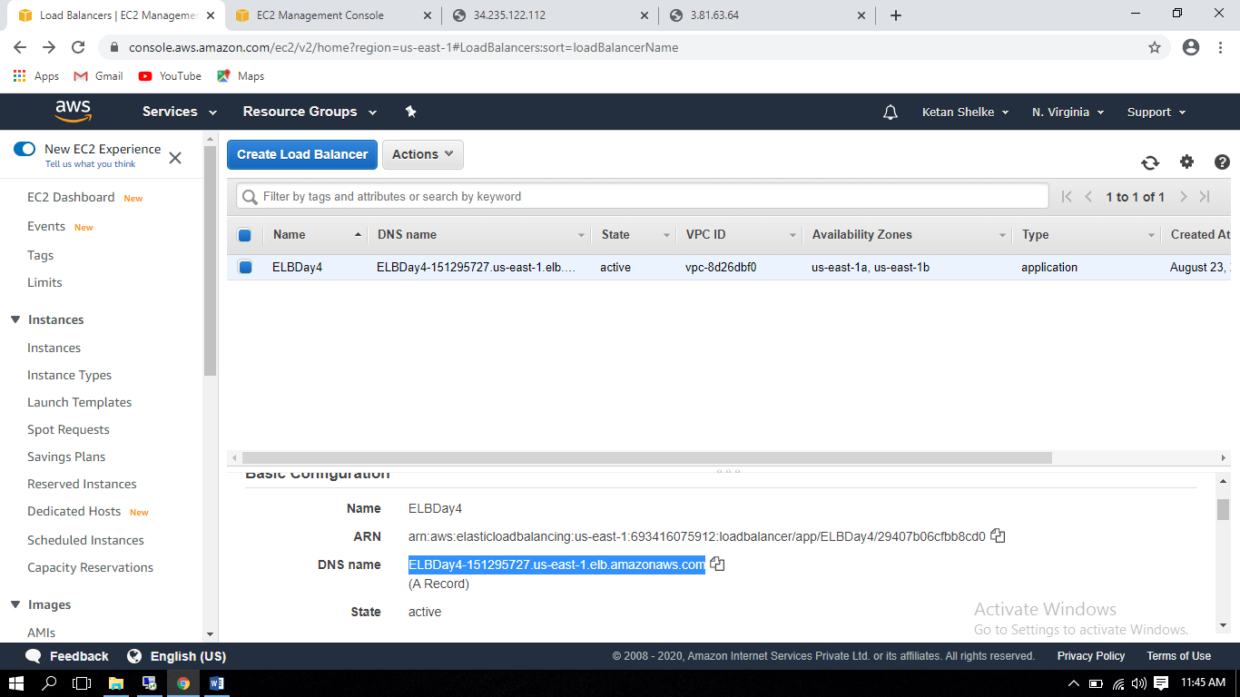

Please Note:

Since Load balancer is not configure yet (Till 24 Aug 2020). I am unable to provide working screenshot for the same. I have created load balancer on 23 Aug 2020 but still it gives the error message.

